Office Signage Template

The College of Arts and Sciences Office of Marketing and Communications has created and approved the template that adheres to brand and accessibility standards. To ensure consistency, all must use this template to create office signage.

How to use this template
This Microsoft Word template makes it easy to create branded office signage for print use only. Please use the following steps to customize your signage.
- Please enter your information where it's indicated on the following few pages.
- Be sure edit/update any highlighted or placeholder copy that will be marked by [brackets].
- Create a QR Code using the directions below to connect your signage with your department’s website or appointment booking website.
- Save your changes and print.

QR Codes

What is a QR code?
The quick response, or QR code is a two-dimensional version of the Barcode able to link directly to a website with the scan of a mobile device.
Visit the HelloTech website to learn how to scan a QR Code >>

How to create a QR code?
Creating a QR Code couldn't be easier. Follow the directions below to get started.
- Visit QR Code Monkey to start building your free QR Code.
- Choose and copy the website URL you'll like your audience to visit when looking at your event poster.
- Paste the website URL under QR Content in the "Your URL" text field.
- Click the green "Create QR Code."
- Once the QR code generates, click the blue "Download PNG."
- Insert the QR Code by selecting the qr-code.png file from your download folder.
- Test the QR code to make sure it works properly by scanning the QR code with your phone.

Best Practices
Use UB Style Guide, a UB customized version of AP Style, as a reference when editing your signage.

Top Style Tips

days, weeks, months
Always use Arabic figures, without st, nd, rd or th. For example: June 1, not June 1st.
Do not abbreviate days of the week, except when needed in a tabular format.
When a month is included as part of a specific date, use Jan., Feb., March, April, May, June, July, Aug., Sept., Oct., Nov., Dec. María Garcia’s birthday is Sept. 12, 1985. Do not abbreviate the names of any months when only a month and year are given: The research project began in January 2000 and ended in November 2003.

telephone numbers
Use figures with hyphens, without parentheses: 716-555-2000.

times
With the exception of noon and midnight, use figures and lowercase a.m. and p.m. The class began at noon and ended at 1 p.m. Haruto Sato skipped the class because he worked from 11 a.m. to 5:30 p.m.

URLs
Don’t include https://www unless it is essential for calling up the website. Usually the simple web address will suffice, for example, buffalo.edu or arts-sciences.buffalo.edu

For more, visit the UB Style Guide website.

Office will be Closed

The Department of [insert Department Name] will be closed on [DATE].
Normal office hours will resume on [DATE].

For more information about the [insert Department Name], please visit our website at [insert URL without the https:// or the .html]
Or by scanning the QR Code below.

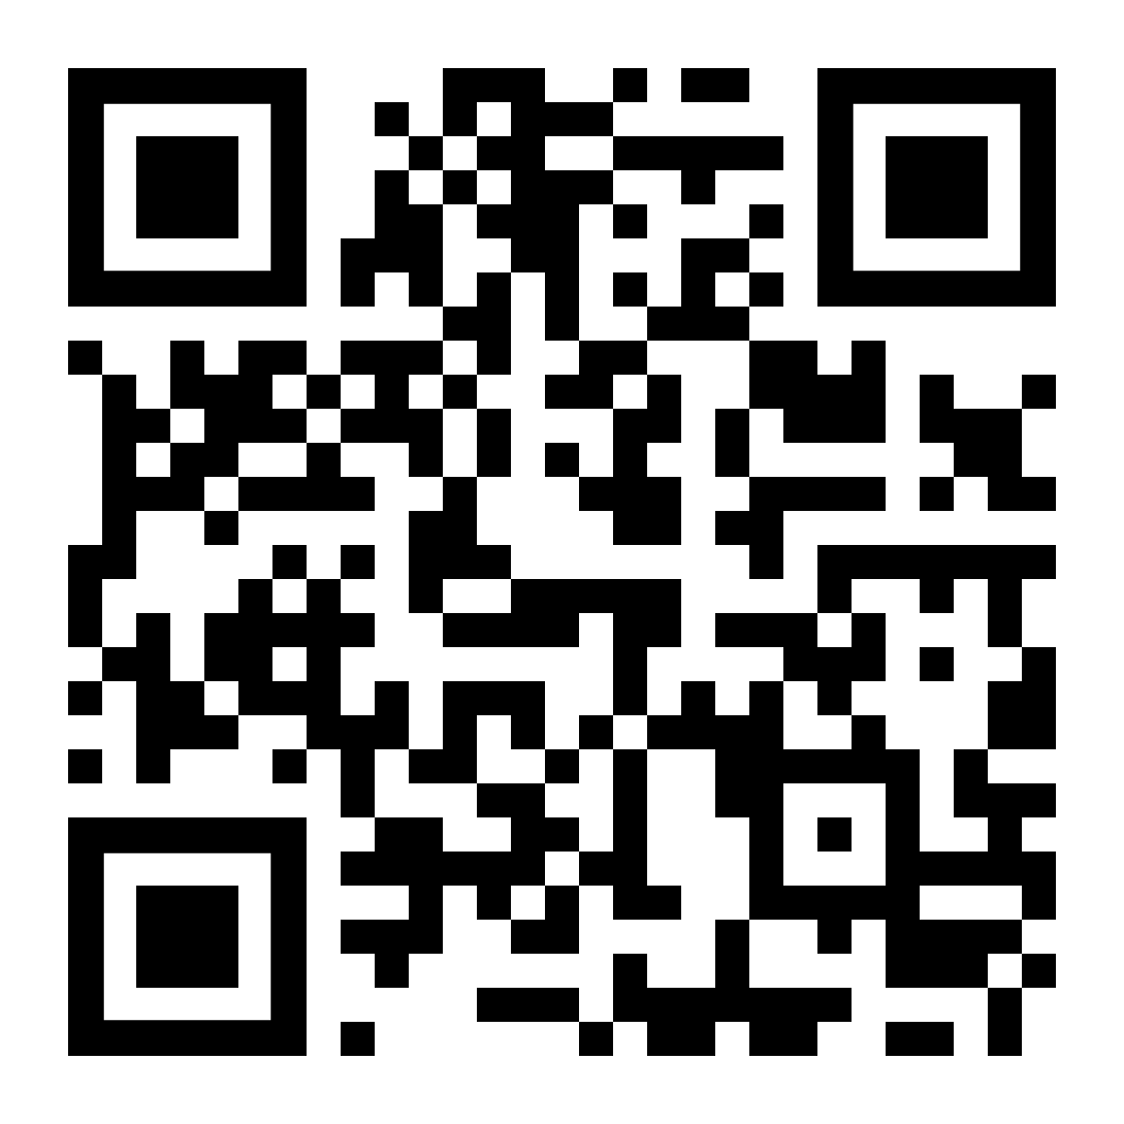
Office Hours

Monday – Friday | 8:30 a.m. to 5 p.m.

For more information about the [insert Department Name], please visit our website at [insert URL without the https:// or the .html]
Or by scanning the QR Code below.

